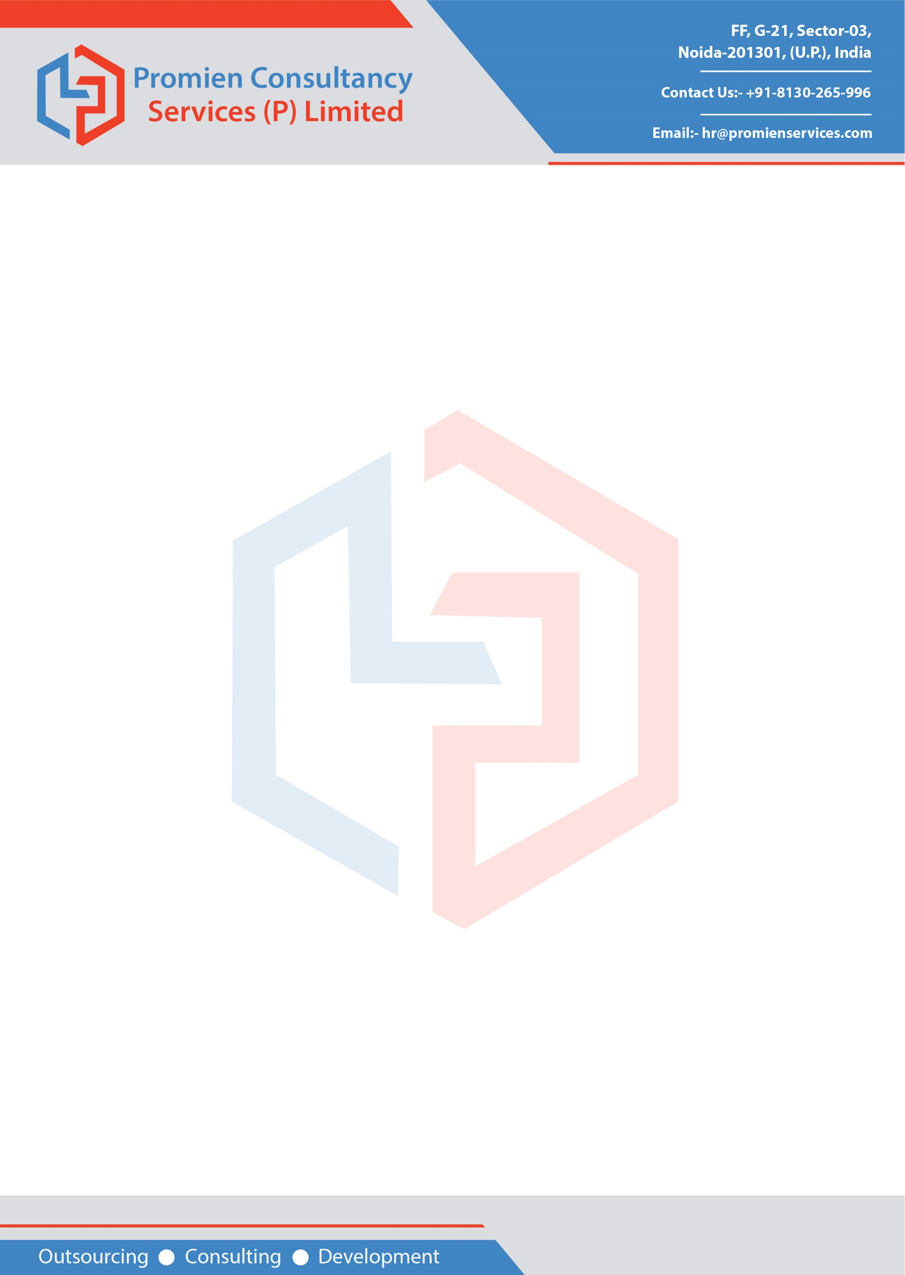

Date: 24-Nov, 2020

**SALARY CERTIFICATE**

This is to certify that **Ms. Deepti Bhatane (PC-2251)** was employed with **Promien Consultancy Services (P) Ltd.** She was worked as **“SQL Developer”**. She was drawn monthly salary **INR 34,500.00** as per following breakup.

|  |  |  |  |
| --- | --- | --- | --- |
| * Date of Joining | 01-Mar, 2018 | | |
| * Date of Birth | 12-May, 1988 | | |
| * Scale of Pay | INR 32,500.00 - 34,500.00 | | |
| **Salary Structure** | | | |
| **Pay Components** | | | **Amount (Rs.)** |
| Basic | | | 15,180.00 |
| HRA | | | 7,590.00 |
| Special Personal Allowance | | | 11,930.00 |
| LTA | | | 1,000.00 |
| Communication Expenses | | | 1,000.00 |
| Medical | | | 1,250.00 |
| **Total Earnings : 37,950.00** | | | |
| **Deductions** | | | |
| **Components** | | **Amount (Rs.)** | |
| PF ( Employee's Contribution) | | 0.00 | |
| Tax Deducted At Source | | 0.00 | |
| Professional Tax | | 0.00 | |
| Others (food/cab/etc) | | 3,450.00 | |
| **Total Deductions : 3,450.00** | | | |
| **Net Payable Salary : 34,500.00**  (Thirty Four Thousand Five Hundred Only) | | | |

For and on behalf of

Promien Consultancy Services (P) Ltd.

Ravinder Pal

Manager-HR